

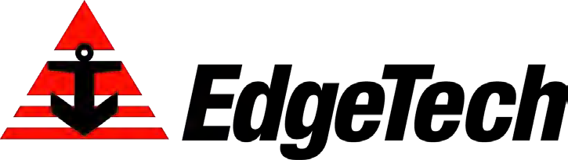
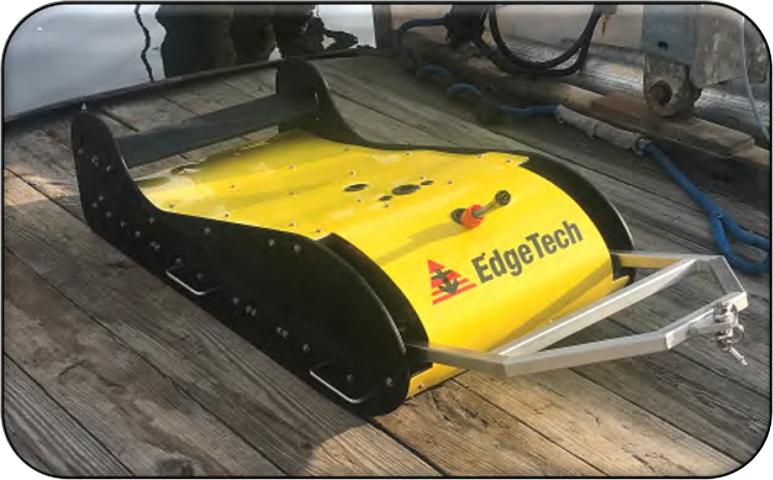
3400

SUB-BOTTOM PROFILING SYSTEMS

Building on the long running success of the EdgeTech sub-bottom profiler product line, the EdgeTech 3400 series provides users many enhancements to current sub-bottom profiler systems. The 3400 is a wideband Frequency Modulated (FM) sub-bottom profiler utilizing EdgeTech’s proprietary CHIRP technology.
FEATURES
- Towed or Pole-mount configurations
- Various Sonar head / towfish frequency ranges to optimize mission goals:
4 - 24 kHz
2 - 16 kHz
1 - 10 kHz
500 Hz - 12 kHz
- Enhanced Sub-bottom PVDF receivers
- Sub-bottom mode or pipeliner mode
- Digital receiver with Ethernet telemetry and power
- Real-time pitch, roll, heave and depth sensors
- Pulse library tailored for different survey applications

APPLICATIONS
- Geological surveys
- Environmental site investigations
- Sediment classification
- Buried pipeline & cable surveys
- Archeological surveys
- Mining/dredging surveys
- Any other applications that require the ability to map, measure & classify sediment layers within the sea floor
The system generates high resolution images of the sub-bottom stratigraphy in oceans, lakes, and rivers and provides excellent penetration in various bottom types.
The EdgeTech 3400 comes in various towed or pole mountable configurations, but all have PVDF receiver arrays segmented for standard sub-bottom profiling operations or a unique “pipeliner” mode for optimal location and imaging of buried pipelines.
The EdgeTech Sub-Bottom Profiler data format allows users the ability to collect complex ‘analytic signal’ data using linear system architecture to measure sediment reflection and analyze sediment type determination. Additionally, the system has discrete transmit and receive channels allowing for continuous data collection resulting in a high ping rate particularly important for construction and pipeline surveys.
Each EdgeTech 3400 Sub-bottom Profiling System comes as a complete package and includes a towfish or sonar head, cable and a topside processor running EdgeTech’s DISCOVER sub-bottom acquisition & processing software. The 3400 can also be interfaced to 3rd party software.



3400 Series
SUB-BOTTOM PROFILING SYSTEMS

 | Portable Systems |  | Standard Systems |  | Lower Frequency and Deeper water systems
System | 3400-OTS Ultralight (Pole mount) | 3400-OTS Light (Pole mount) | 3400 Dual 216  (Towed) | 3400 Dual 216  (Towed or Pole mount) | 3400 Dual 216  (Towed) | 3400-OTS LF  (Low Frequency Pole mount) | 3400 0512e  (Towed)
 | 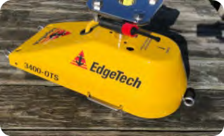 |  | 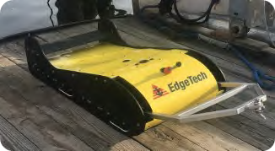 | 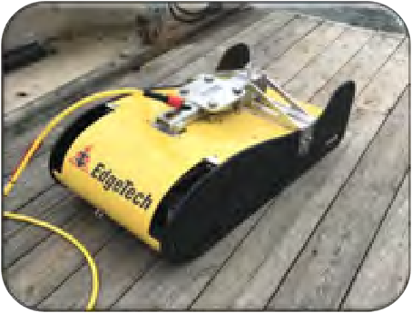 | 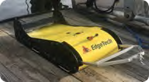 | 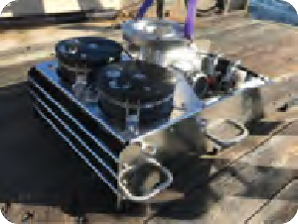 | 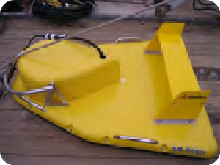
Frequency | 4-24 kHz | 2-16 kHz | 2-16 kHz |  | 2-16 kHz | 1-10 kHz | 500 Hz – 12 kHz
Number of Transducers | 1 | 1 | 2 |  | 2 | 2 | 1 + 1
Typical Penetration In coarse sand  In clay | 2 m  40 m | 6 m  80 m | 8 m  100 m |  | 8 m  100 m | 20 m  200 m | 20 m  200 m
Vertical Resolution | 4 – 8 cm | 6 – 10 cm | 6 – 10 cm |  | 6 – 10 cm | 10 – 30 cm | 8 – 20 cm
Towfish / Sonar head size | 70 x 38 x 36 cm 21 kg (in air)  27 kg (in air) with flange | 70 x 38 x 36 cm 26 kg (in air)  33 kg (in air) with flange | 116 x 56 x 34 cm 90 kg (in air) | 116 x 56 x 43 cm 84 kg (in air) | 116 x 56 x 34 cm 90 kg (in air) | 117 x 75 x 51 cm 145 kg (in air) | 160 x 124 x 47 cm 204 kg (in air)
Topside Configuration | 3400 with Laptop |  | 3400 with Laptop |  | 3400 with rackmount PC and rackmount amplifier
Standard Cable | 20m deck cable |  | 50m tow cable | 50m tow cable & 20m deck cable | 50m tow cable | 50m deck cable | 50m tow cable

3400 Series
SUB-BOTTOM PROFILING SYSTEMS

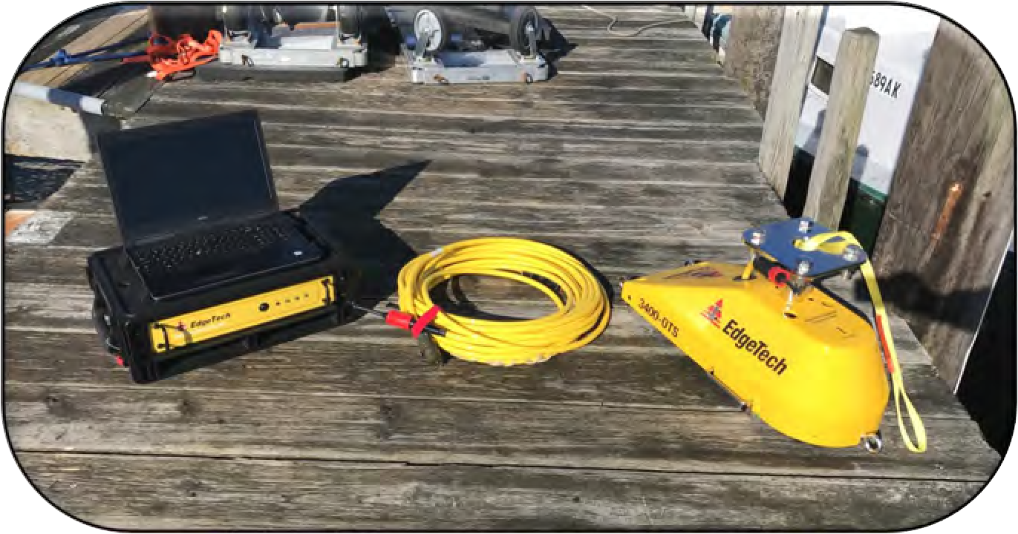
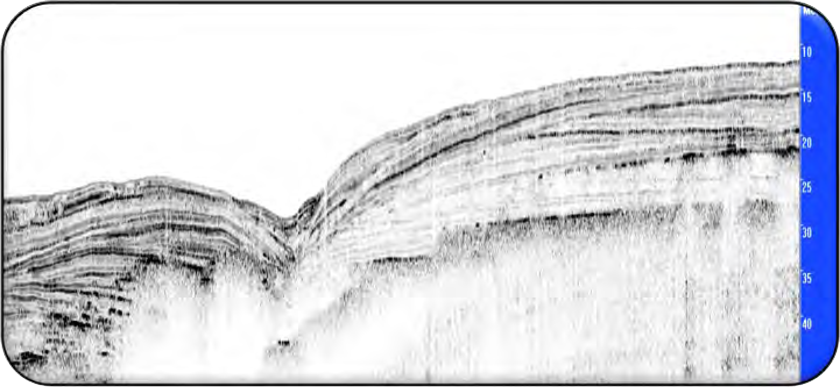
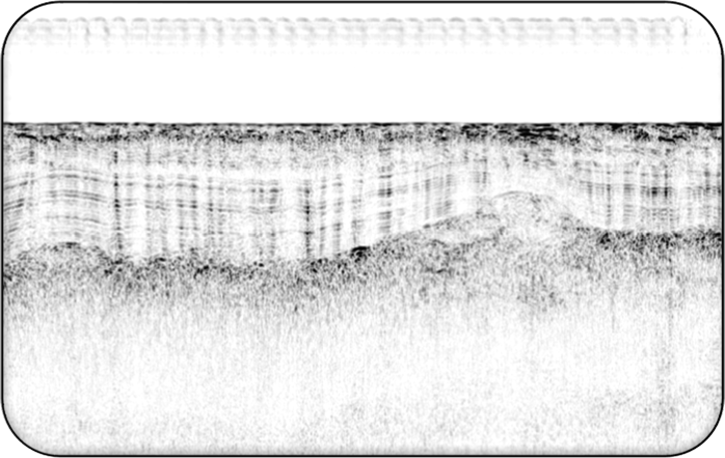
Portable Systems
The 3400-OTS Light and Ultra-Light systems are based on a small,
light, sonar head and as such are ideal for customers that require a system that can be used from smaller boats while still maintaining many of the 3400 system benefits and the associated image quality.
The same sonar head body is used for both the Light and Ultra-
Light, the difference being the transmit transducer used. However, we would generally only recommend the Ultra-Light, based on the 4-24 kHz transducer, for work in lakes and marsh areas, with soft sediments, where it can provide reasonable penetration, and the benefit of the ultra-high resolution can then be exploited. Although marginally heavier, the 3400-OTS Light, based on the 2-16 kHz transducer, is generally the preferred tool for coastal and offshore work.
Standard Systems
The Standard 3400 towfish has dual 2-16 kHz transmit transducers
and a large multi-channel PVDF based panel receive array.
The 3400 is designed to be towed relatively near the surface and comes with a standard 50m cable for towing. This shallow tow approach is fine for regional geological analysis, where the area insonified on the seabed is not that critical.
There is the option to add additional hardware such that the tow body can be pole mounted.
Finally, there is also the option to upgrade the system to have a
higher power amplifier. This provides an increased source level, which in turn compensates for the spreading losses through the water column, and therefore allows the system to maintain performance in deeper water operations.
Low Frequency Systems
There are two lower frequency systems that complete the 3400
series.
The 3400-OTS LF is a large pole mountable system that utilizes dual 1-10 kHz transducers to deliver the improved penetration that lower frequencies can provide.
The 3400 0512e (500 Hz – 12 kHz) uses an updated version of the
old 0512 towfish where the benefits of a large PVDF receive array, digitization in the towfish and a built-in heave sensor, all features associated with the 3400 product range, provide a modern twist on an old favourite.

3400 Modes of Operation
SUB-BOTTOM PROFILING SYSTEMS

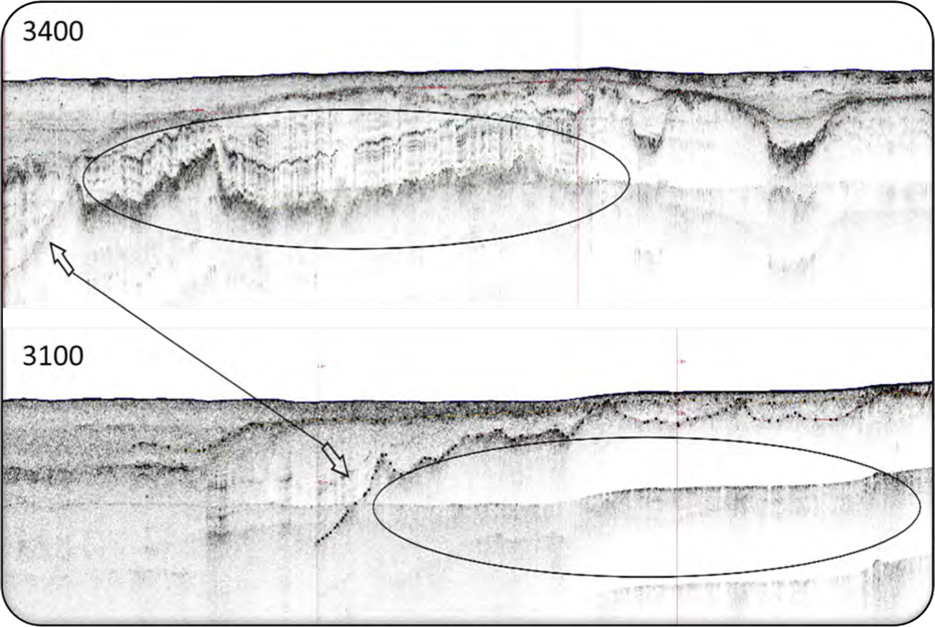
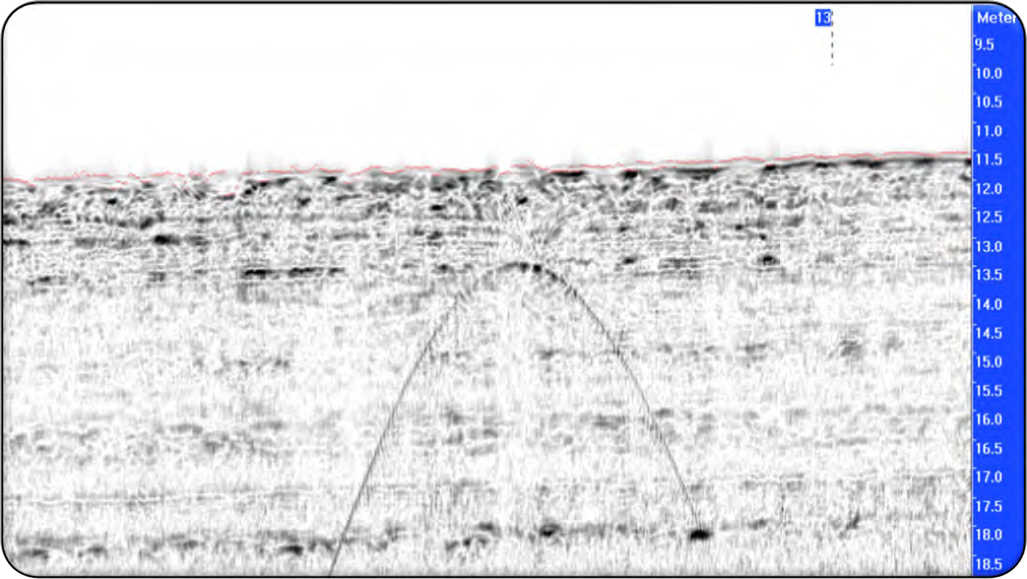
Standard Survey Mode
In standard survey mode, the large sub-array is used to provide improved beam patterns and
therefore improved signal to noise ratios and cleaner data.
Pipeliner Mode
In pipeliner mode, a smaller sub-array is used to increase the fore-aft beamwidth, and therefore
accentuate the ‘tails’ seen on the hyperbola created by the dataset by the pipe / cable when running cross-lines. This makes it much easier to identify and map the pipe / cable position.

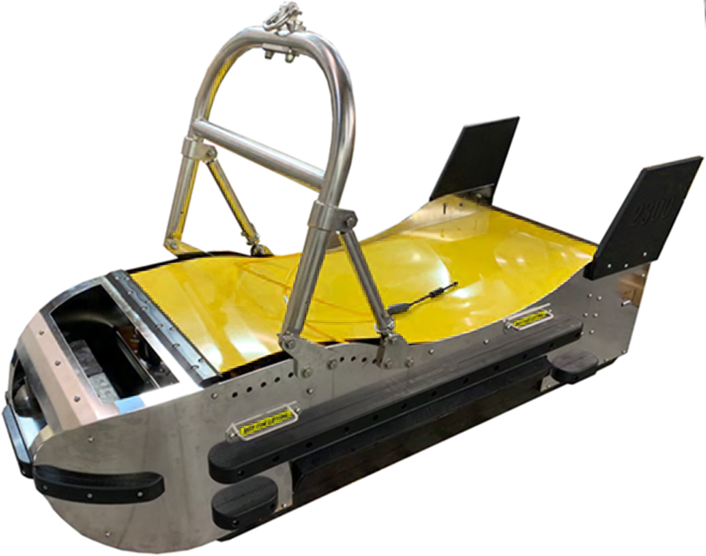
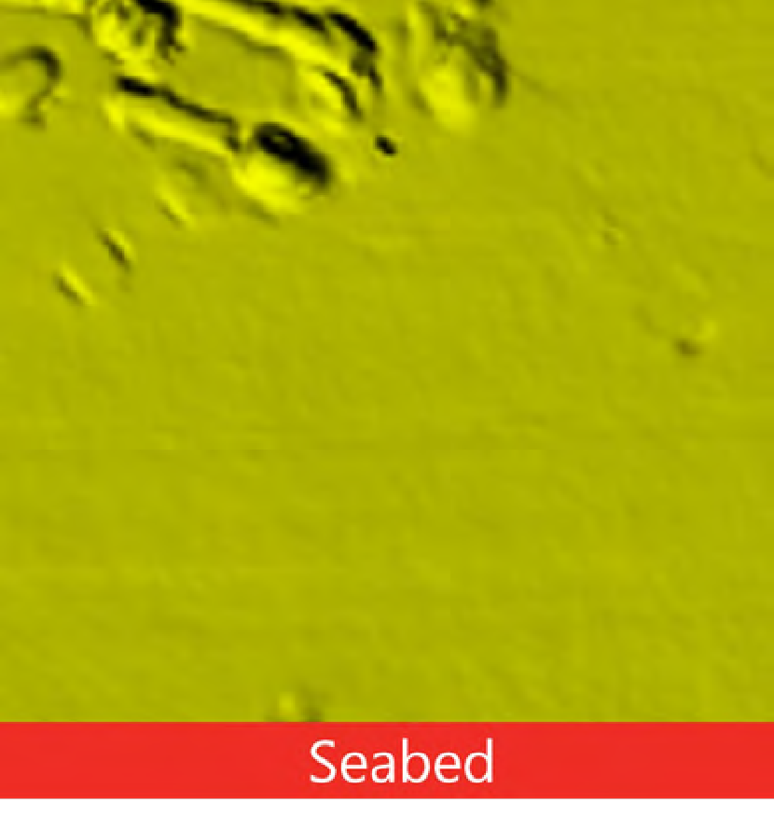
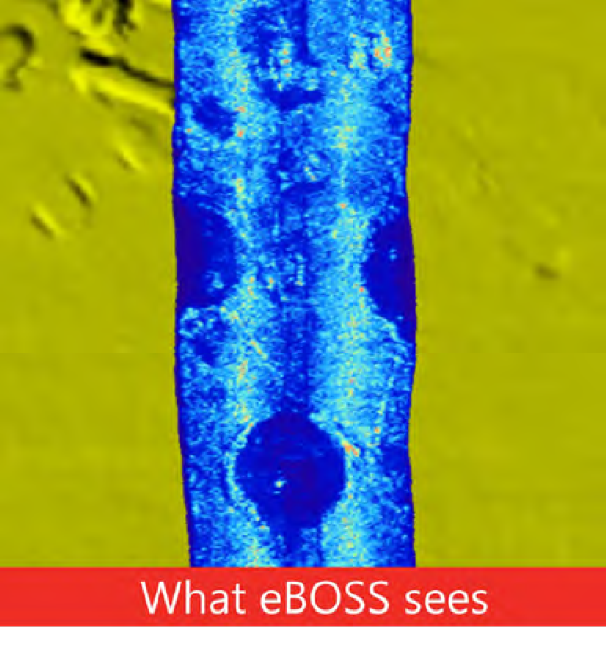
Combined Side Scan Sonar and
Sub-Bottom Profiler Systems
Towfish that combine the ability to collect sub-bottom profiler data with a side scan sonar are ideal
for deeper water operations, and for applications where the area insonified on the seabed by the sub-bottom profiler should be kept to a minimum. This might include pipeline / cable route surveys, or subsea installation site surveys.
The 2050-DSS offers tri-frequency side scan, with the system able to operate any two of the three frequencies simultaneously, in conjunction with a single transducer 2-16 kHz Sub-Bottom Profiler. The main purpose of the tri-frequency side scan capability is to allow the same tow vehicle to be used for a range of survey tasks.
The 2300 and 2300B combine a tri-frequency side scan with a four 1-10 kHz transducer Sub-Bottom Profiler for unparalleled sub-bottom performance from a deep towed vehicle.
eBOSS
The EdgeTech Buried Object Sonar System (eBOSS) is an advanced sub-bottom sonar system capable
of providing 3D images that allow the user to accurately detect, locate, classify, and identify buried and partially proud objects.
AUV, USV and ROV/ROTV Systems
In addition to systems deployed on our own towfish, EdgeTech can provide systems based on our sub-
bottom electronics, transducers and receiver arrays, that can be ‘hosted’ on a wide variety of 3rd party vehicles, including AUV’s, USV’s, ROV’s and ROTV’s.
These could be sub-bottom profiler only systems, or systems that combined sub-bottom profiler with other sensors, such as side scan sonar, or combined side scan sonar and bathymetry systems.

Other
SUB-BOTTOM PROFILING SYSTEMS

