Overview

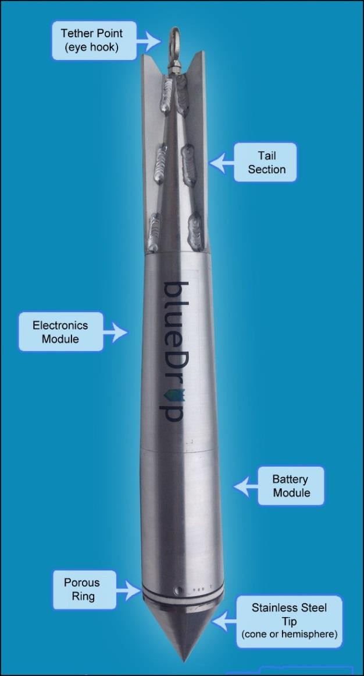
The bCd blueDrop is a small dynamic penetrometer with the ability to collect In-situ measurements of surface sediments in areas with difficult access (e.g., narrow canyons, close to offshore constructions and highly energetic areas) down to 200m water depth. This lightweight instrument is suitable for deployment from any vessel of opportunity. Its streamlined shape is based on a hydrodynamic design which includes fins and a fall-stabilizing relationship between the center of mass and center of volume. The aluminum housing encloses the electronics, redundant battery packs and sensors (6 accelerometers and a pressure transducer).
The blueDrop:
  - Free-falls through the water column and impacts the seabed
  - Records acceleration and dynamic pore pressure during penetration
  - Used for sediment classification and predicting shear strength

Tether Point:
Ensure the tether is secured to the designated anchorage point (eye hook).

Electronics Module:
5 single axis (vertical) accelerometers ranging from
+/- 1.7g to +/-250 and 1 dual axis (horizontal) accelerometer with a range of +/-55g.

DataLogger: records high resolution data: 24 bit ADC at 2000 scans/second, 8 channels.

Battery Module:
Dual/redundant impact resistant rechargeable battery packs.
Pressure Transducer: measures hydrostatic and pore pressure response.

Porous Ring:
Porous filter behind the tip.

Steel Tips:
The probe is shipped with two steel tips (60° cone and elliptical).

Figure 1

